**Item Registry App**

# Introduction

The **Item Registry App** is a simple mobile application developed using Flutter. Its main purpose is to help users manage a list of items that can later be used in a Point of Sale (POS) system.

With this app, you can

* Add new items with details like name, SKU (item code), category, price, supplier, and expiry date.
* View all registered items in a clear, searchable list.
* Edit an item if details change.
* Delete an item if it is no longer needed.

This app is designed with simplicity in mind anyone can quickly understand how to use it without technical knowledge.

# How to Install the App

Option A: Install the APK (For Normal Users)

1. Get the APK file (app-release.apk) from the project submission or GitHub repository.
2. Copy the file to your Android device.
3. On your phone, go to **Settings > Security > Install Unknown Apps** and allow installation.
4. Open the APK file and tap **Install**.
5. Once installed, look for the app called **Item Registry** in your apps list and open it.

Option B: Run from Source Code (For Developers)

1. Make sure **Flutter SDK** is installed on your computer (run flutter doctor to confirm).
2. Download or clone the project from GitHub. Example:

git clone https://github.com/YousufMahdoom/item_registry_app

cd item_registry

1. Install all required packages:

flutter pub get

1. Connect an Android device (or start an emulator) and run:

flutter run

# App Features and How to Use Them

## Home Screen

* When you open the app, you will see the **Registered Items** page.
* At the top, there is a **search bar** where you can type an item name or SKU to quickly find an item.
* Each item is displayed in a card format, showing its name, SKU, category, and price.
* To add a new item, tap the **+ button** in the top-right corner.
* To manage an existing item, tap the **three dots (⋮)** beside it for options.

## Adding a New Item

1. Tap the **+ button**.
2. You will see a form with fields like:
   * **Item Name** (required)
   * **SKU / Item Code** (required)
   * **Category** (e.g., Grocery, Beverages)
   * **Unit of Measurement** (pcs, kg, ltr, etc.)
   * **Base Price** (required)
   * **Retail Price** (optional)
   * **Supplier Name** (optional)
   * **Expiry Date** (optional, select using a date picker)
3. After filling in the details, press **Save Item**.
4. The item will appear in your Registered Items list.

## Editing an Item

1. On the Home screen, find the item you want to change.
2. Tap the **three dots (⋮)** and choose **Edit**.
3. Update the information in the form.
4. Tap **Update Item** to save changes.

## Deleting an Item

1. On the Home screen, tap the **three dots (⋮)** next to the item.
2. Select **Delete**.
3. Confirm the deletion. The item will be removed from the list permanently.

# Behind the Scenes (For Developers)

* The app uses **Hive**, a lightweight database, to store all items locally.
* Items stay saved even after closing or restarting the app.
* Each item is stored with a unique ID generated by the uuid package.
* The main dependencies used are:
  + **hive** (for storage)
  + **hive_flutter** (for Flutter integration)
  + **path_provider** (for locating storage path)
  + **uuid** (for unique IDs)

# Workflow of the App

Here’s a simple way to understand how the app works:

1. You open the app → Home screen shows all saved items.
2. When you tap **Add**, a form opens → you enter item details → item is saved into Hive database.
3. Items are displayed in the Home screen list.
4. You can **edit** an existing item → updated data replaces the old one.
5. You can **delete** an item → it is removed from the Hive database.

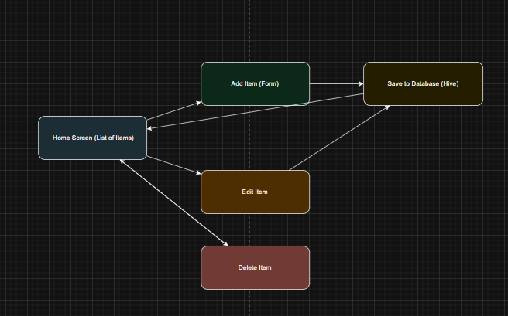

# Notes & Limitations

* Currently, the app only works offline (local storage). Items are saved on your device only.
* Data does not sync across multiple devices.
* Works on Android 6.0 (API level 23) and above.
* Firebase integration can be added in the future for cloud storage.